
Curb Ramp Inspection ITD 0288 (Rev. 10-14)
itd.idaho.gov

Send a completed copy of this form to the ITD Office of Civil Rights.

Key Number |  | Project Number |  | Project Name |  |  | Ramp ID Number
District | City |  |  |  | County | Highway |  | Milepost
Inspection Date |  |  | Inspected By (Print) |  |  |  | *Technical Infeasibility
 |  |  |  |  |  |  | Yes No

Ramp Location | Location in Intersection | Curb Ramp Type
Intersection  Mid-block | N E NW NE  S W SW SE | Parallel Perpendicular Combined
Describe Ramp Location (details to help locate it, such as “next to gas station”)

Note - The elements numbered 1 - 7 below correspond to smart level measurement locations detailed on page two of this form

Ramp Details | Ramped Area 1 | Ramped Area 2 | Ramped Area 3 | Ramped Area 4
Ramp Width (48” minimum)
- Running Slope (8.3% maximum)
- Cross Slope (2% maximum)
- Flare Slope A (10% maximum)
- Flare Slope B (10% maximum)

Landing (Turning Space)
Landing (Turning Space) Provided | Width (48” minimum) | Depth (48” minimum) | 5. Cross Slope (2% maximum - both directions)
Yes No

Detectable Warning Surface
Detectable Warning Depth (24” minimum) | Detectable Warning Spans Curb Cut | Truncated Dome Spacing Correct
 | Yes No | Yes No
Within 5’ of the Curb Line/Grade Break | Color Contrast (e.g., Light on Dark or Dark on Light)
Yes No | Yes No

Transition Details
Lip Present (> ¼ inch) | 6. Gutter Flowline Slope at Ramp (2% maximum) | 7. Gutter Counter Slope (5% maximum)
Yes No

Pedestrian Crossing Details
Pedestrian Signal Pushbutton | Pushbutton Height within 15" to 48" | Pushbutton within 10” of clear space | Crosswalk Clear Space
Yes No | Yes No | Yes No | Yes No

Comments - *If construction of a compliant curb ramp is not technically feasible, explain each specific reason)
Inspector’s Signature | Date

ADA Ramp Inspection Details

A ramp gradient measurement is required at locations marked with smart level below
Detectable Warning (Truncated Domes)

Perpendicular Curb Ramp - 1 Ramped Area
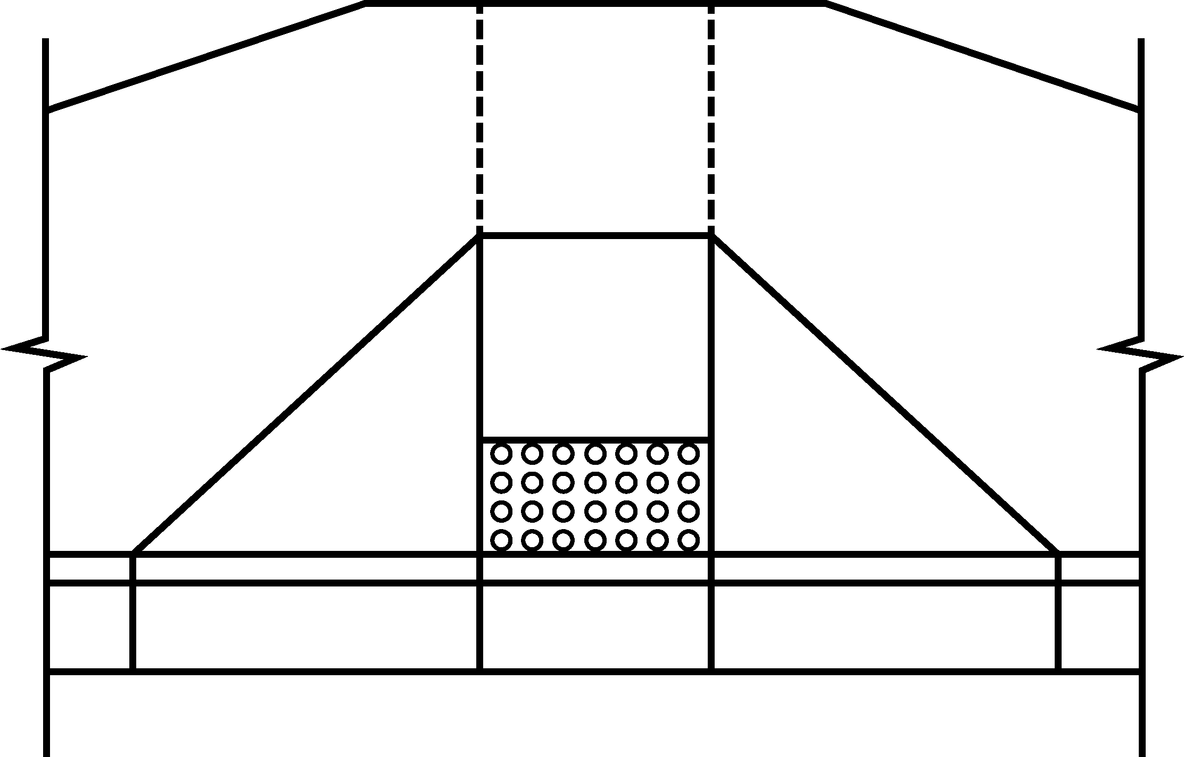
Landing (Turning Space)
Tur

5

1
2

Ramp

Flare
Flare

3
4

6
Gutter Counter Slope

Gutter Flowline
Ramp Transition location–no lip >1/4”should be present
7

Parallel Curb Ramp - 2 Ramped Areas
Combination Curb Ramp - 3 Ramped Areas
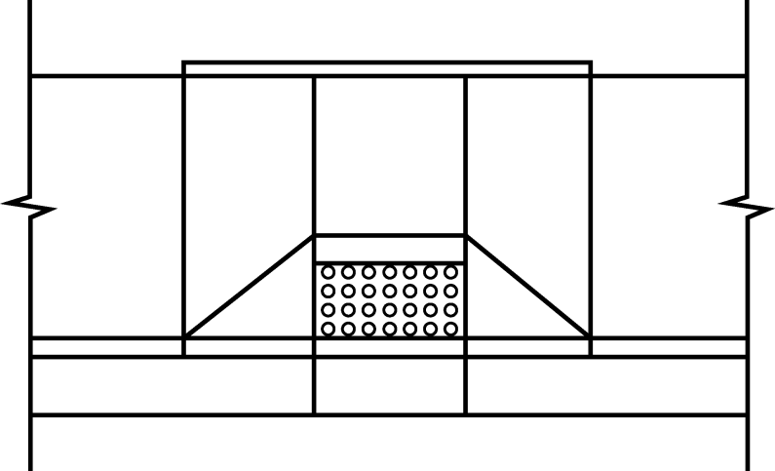
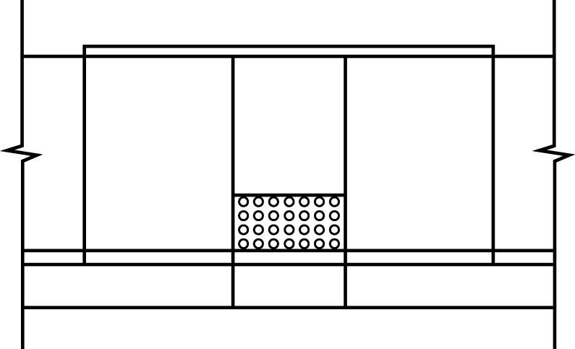

Landing
(Turning Space)
Landing
(Turning Space)
Ramp
Ramp
Ramp
Ramp

Flare
Flare

Ramp

Additional Resources

For detailed information on design parameters, please reference ITD’s standard drawings online at:
http://www.itd.idaho.gov/design/StandardDrawings.htm

