First Name | Last Name | Cell | E-mail | Hotel Room - night of 3/15/16 (Y/N) | Room Share with… | Special Requests
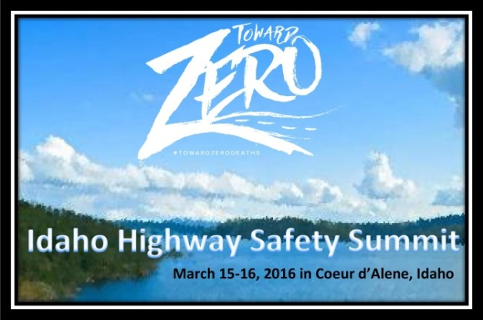
A total of 16 breakout workshops and three main presentations will be offered. Subjects will include but are not limited to the following topics:
Winter pile up crash study
What the eye does and does not see: Portable/Wearable Video evidence for traffic safety
The Silver Bullet of DUI Investigations
Distracted driving case study
Traffic Enforcement Grant management – Available Funding & Paperwork
Prosecuting the Distracted Driver
Child Passenger Safety
Why we don’t enforce motorcycle rider laws
Administrative License Suspension
Alcohol Beverage Control
DRE/ARIDE/SFST
Highway Safety Improvement Plan – State and Local Opportunities
A separate form is available for vendors and speakers.
Participant Registration Form
Send completed registration to:
ITD Office of Highway Safety, Attn: Lisa Losness, PO Box 7129, Boise, ID 83707
e-mail: lisa.losness@itd.idaho.gov, or fax (208) 334-4430.
Tuesday, March 15, 2016
1:00–1:30 Main Session Opening Ceremony
1:30–2:30 Keynote Address
2:45–3:45 Workshops
3:45–4:00 Break
4:00–5:00 Workshops
6:00–8:00 Vendor Reception
AGENDA-AT-A-GLANCE
Wednesday, March 16, 2016
8:00–8:30 Plenary Breakfast
8:30–9:30 Keynote Speaker
10:00–12:15 Workshops
12:15–1:15 AWARDS LUNCHEON
1:30–2:30 Workshops
2:30-3:00 Closing Ceremony

Transportation:
If you are an overnight guest, hotel parking is $18 per night. There is a day rate at the garage for non-hotel guests. There is also an open free parking lot just west of the hotel off of Northwest Blvd. and N. Idaho Centennial Trail at Independence Point Park.

The nearest commercial airport is located 40 mi. west of Coeur d’Alene in Spokane. If needed, a shuttle from the airport to the hotel is available which must be arranged 24 hours in advance by contacting 800-688-75253 x7133 or completing an online form. Round trip shuttle is $69 per person.
Accommodations:
Fifty-five (55) hotel rooms will be provided to Idaho attendees at THE COEUR D’ALENE for one night. You must be traveling at least 100 miles to the Summit to be eligible for a room. To maximize the number of attendees, we strongly encourage you to room share with those from your same agency (two queen beds). Rooms will be reserved for up to two (2) participants from each agency on a first-come, first-serve basis. If you plan to stay an additional night or if the 55 rooms are full, you are responsible for making the reservation and paying the room fee to the hotel directly.
Organization: ______________________________________ Phone: __________________________________

Address: __________________________________________ City: ___________________ State:__ Zip: ______

Registration contact: _________________________ E-mail for confirmation: ____________________________

