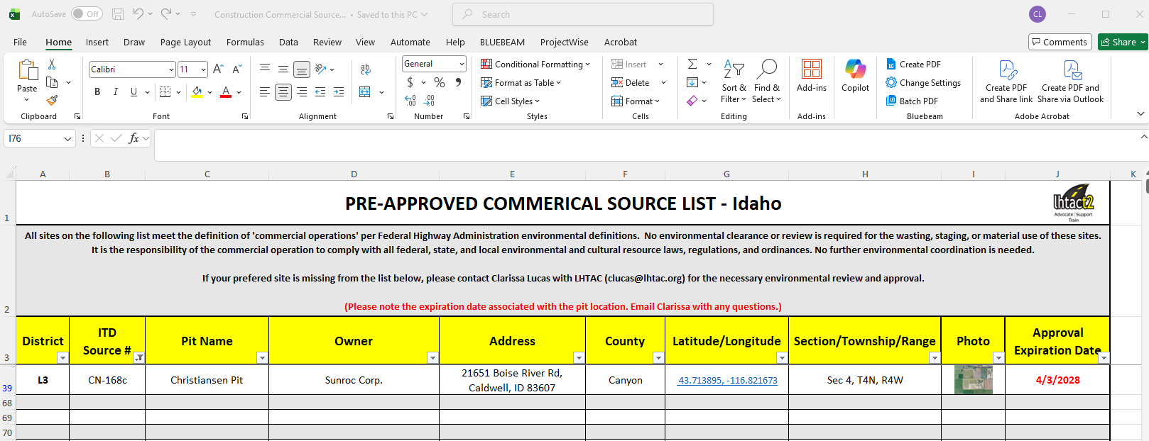
- Click on the ‘Sort & Filter’ button from the ribbon.
- If only a few sources pop up, there may be a filter on.
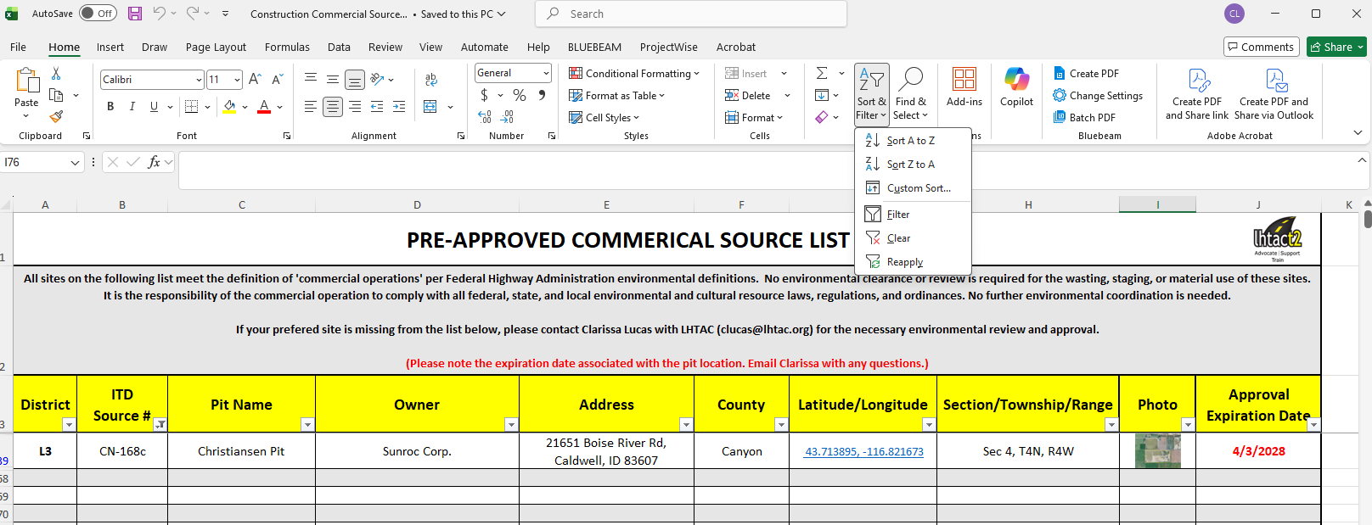
- Click ‘Clear’ button from the ribbon.
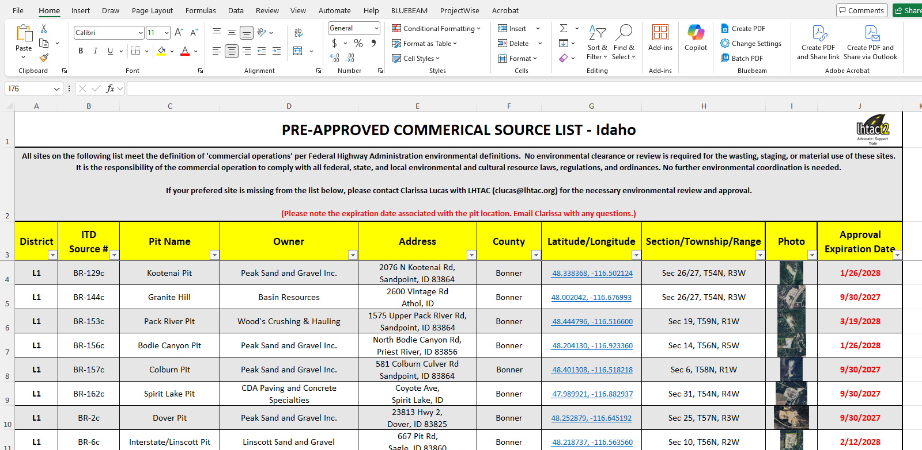
- All approved sources should now be visible.

